Name Date

- Label the diagram of a nerve cell below.
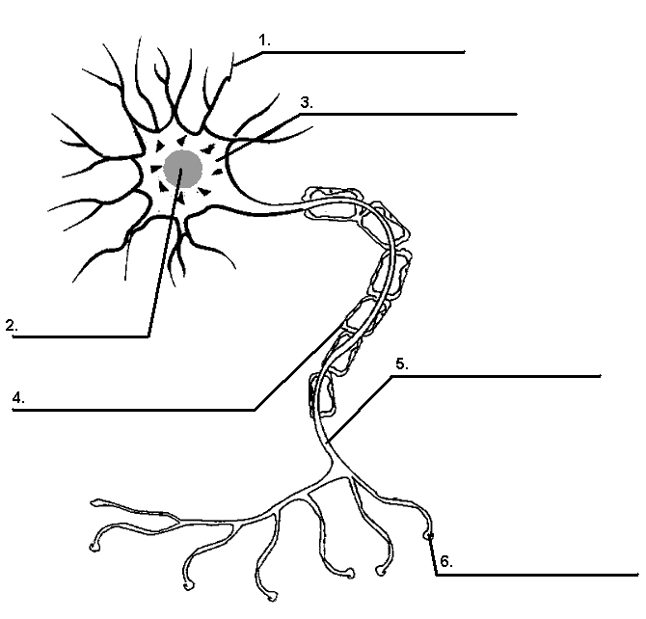

- Fill in the chart below describing the differences between reflexes and reaction time:
 | Reflexes | Reaction Time
Purpose for body

Relative speed (fast/slow)

Number of neurons involved

Controlled by what part of the body?

- Use the keywords below to label the reflex arc diagram. Each term will be used once.

keywords:
- sensory neuron
- motor neuron
- spinal cord
- interneuron
- message to the brain
- receptors in the skin (feel heat & pain)
- effector (muscle in the arm)
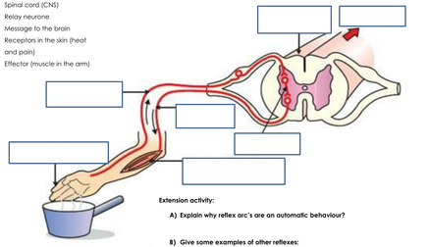

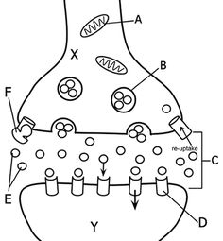
4. Refer to the picture to the right, which shows the junction where 2 neurons communicate with each other. Cell X is the pre-synapse neuron and Cell Y is the post-synapse cell. The area where they meet is called the synaptic junction. Write the letter next to the terms below which correspond to the diagram at the right.

a. Neurotransmitter protein
b. Receptors
c. Mitochondria of neuron
d. Vesicle
e. Synapse

