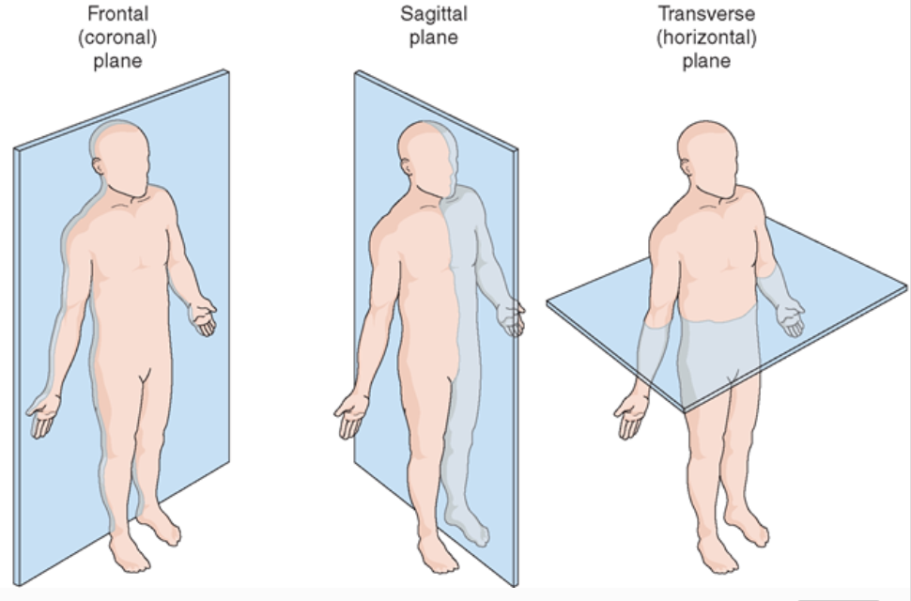

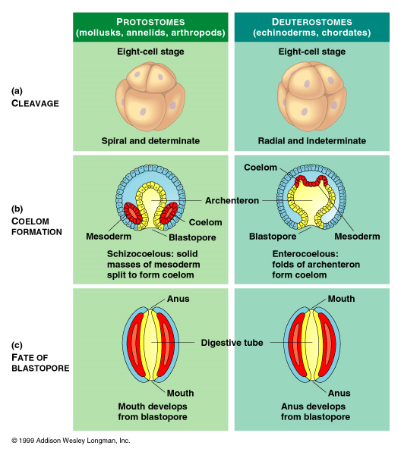

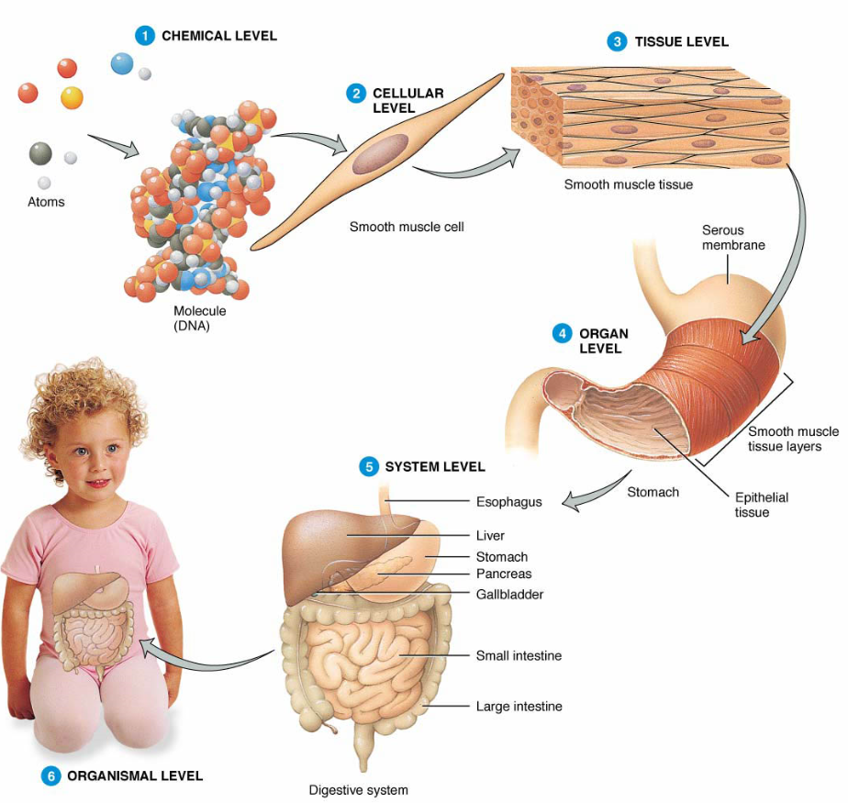

Immune System:
Major Histocompatibility Complex:
Cell Mediated Immunity:
Humoral Immunity:

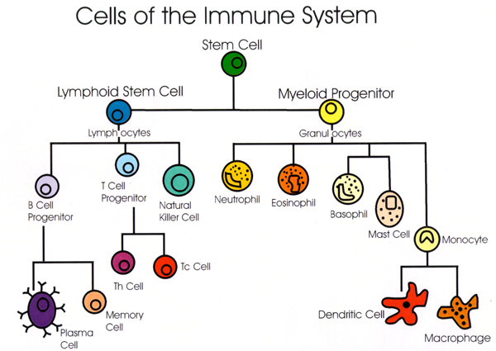
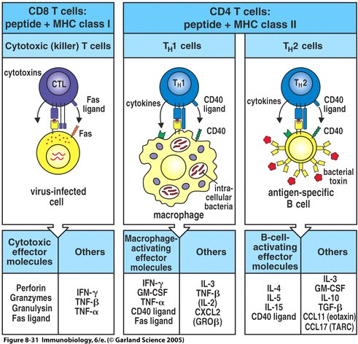
Antigen Presenting Cell

T-Helper Cell

Cytotoxic T-Cell

Plasma B-Cell

Macrophage

Immunoglobulins (Ig’s)

Perforin

Interleukin

Interferon

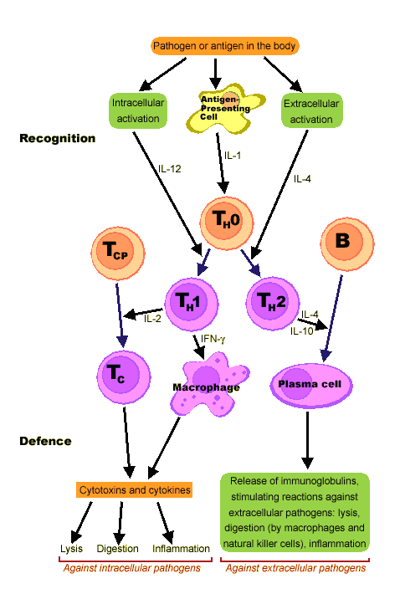

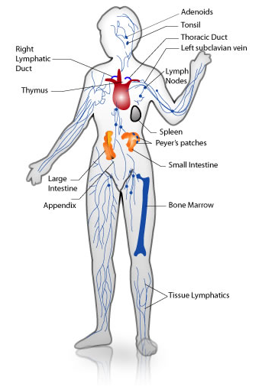
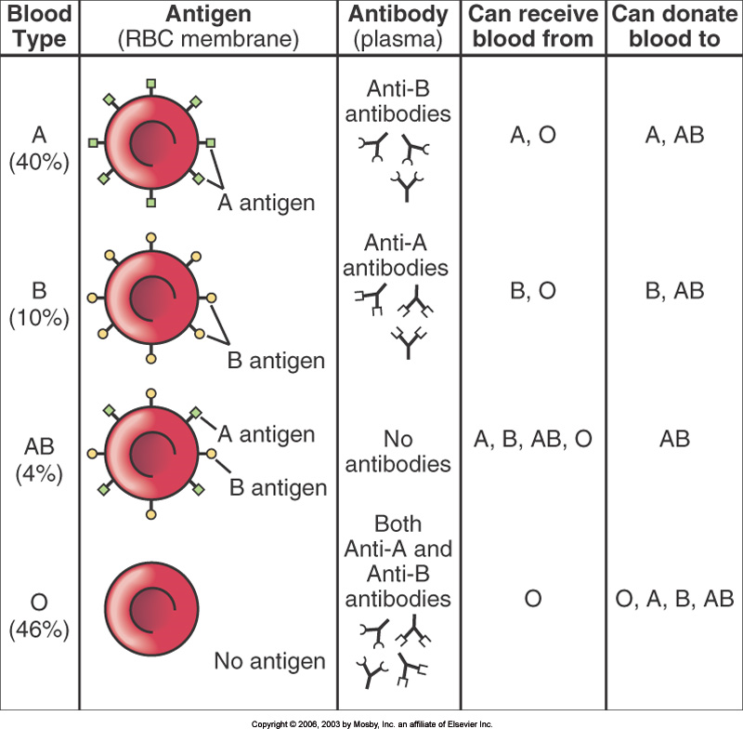

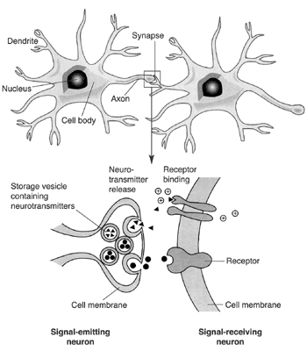
Nervous System:
Neuron:
Synapse:
Neurotransmitter:
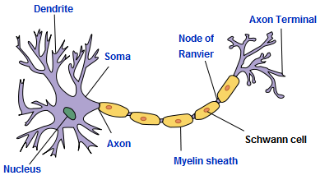

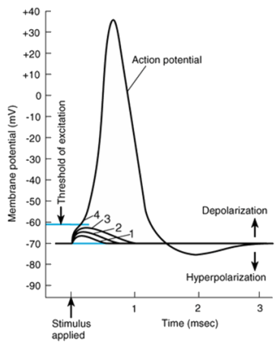
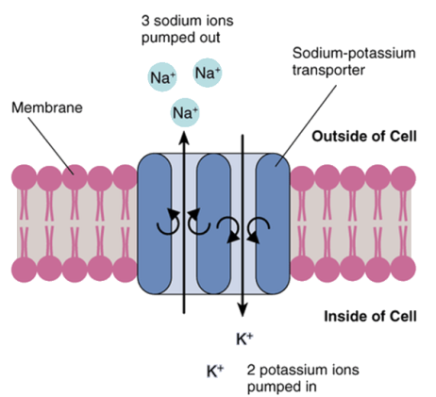
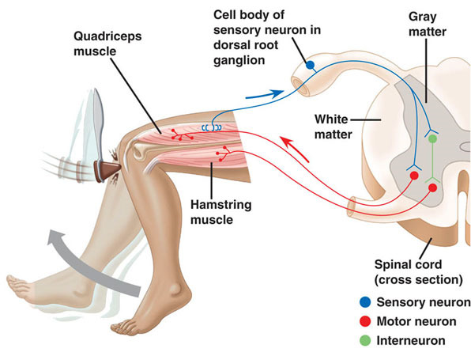
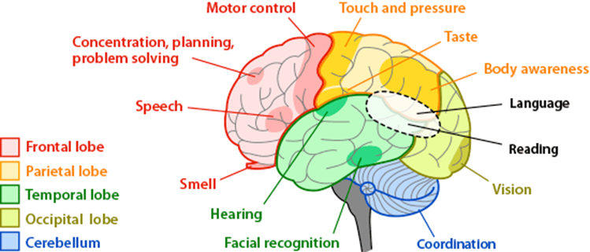

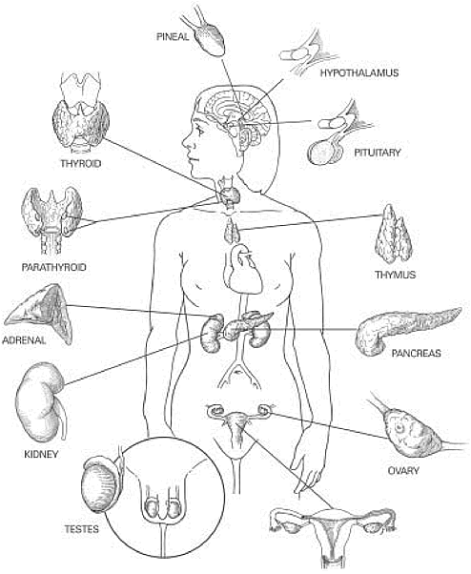
Endocrine System:
Feedback:
Homeostasis:

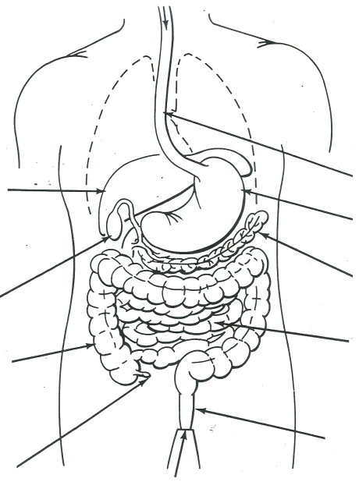
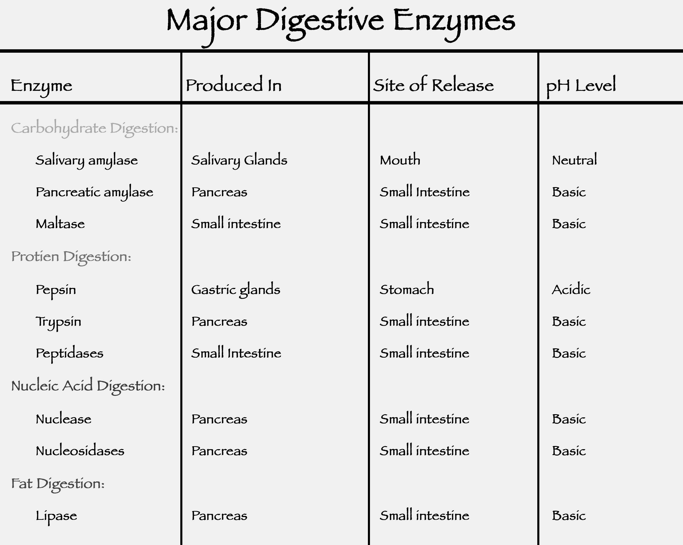
Gland | Hormone(s) | Function

Villi absorb nutrients in the small intestines:
Digestive System:
Mechanical Digestion:
Chemical Digestion:
Intracellular Digestion:
Extracellular Digestion:
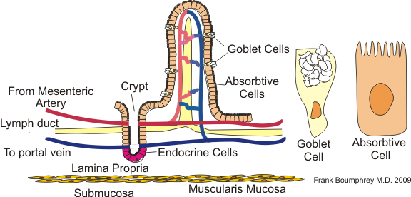

Organs | Functions
Mouth/Pharynx
Salivary Glands
Esophagus
epiglottis
Esophageal & Pyloric Sphincters
Stomach

rugae
Liver
Gall Bladder
Pancreas
Small Intestine
duodenum
jejunum
ileum
Large Intestine
cecum
appendix
rectum
Anal Sphincter

Circulatory System:

Lymphatic System:

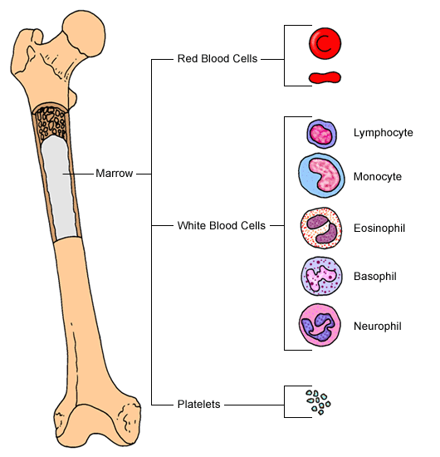
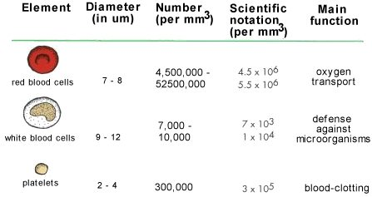
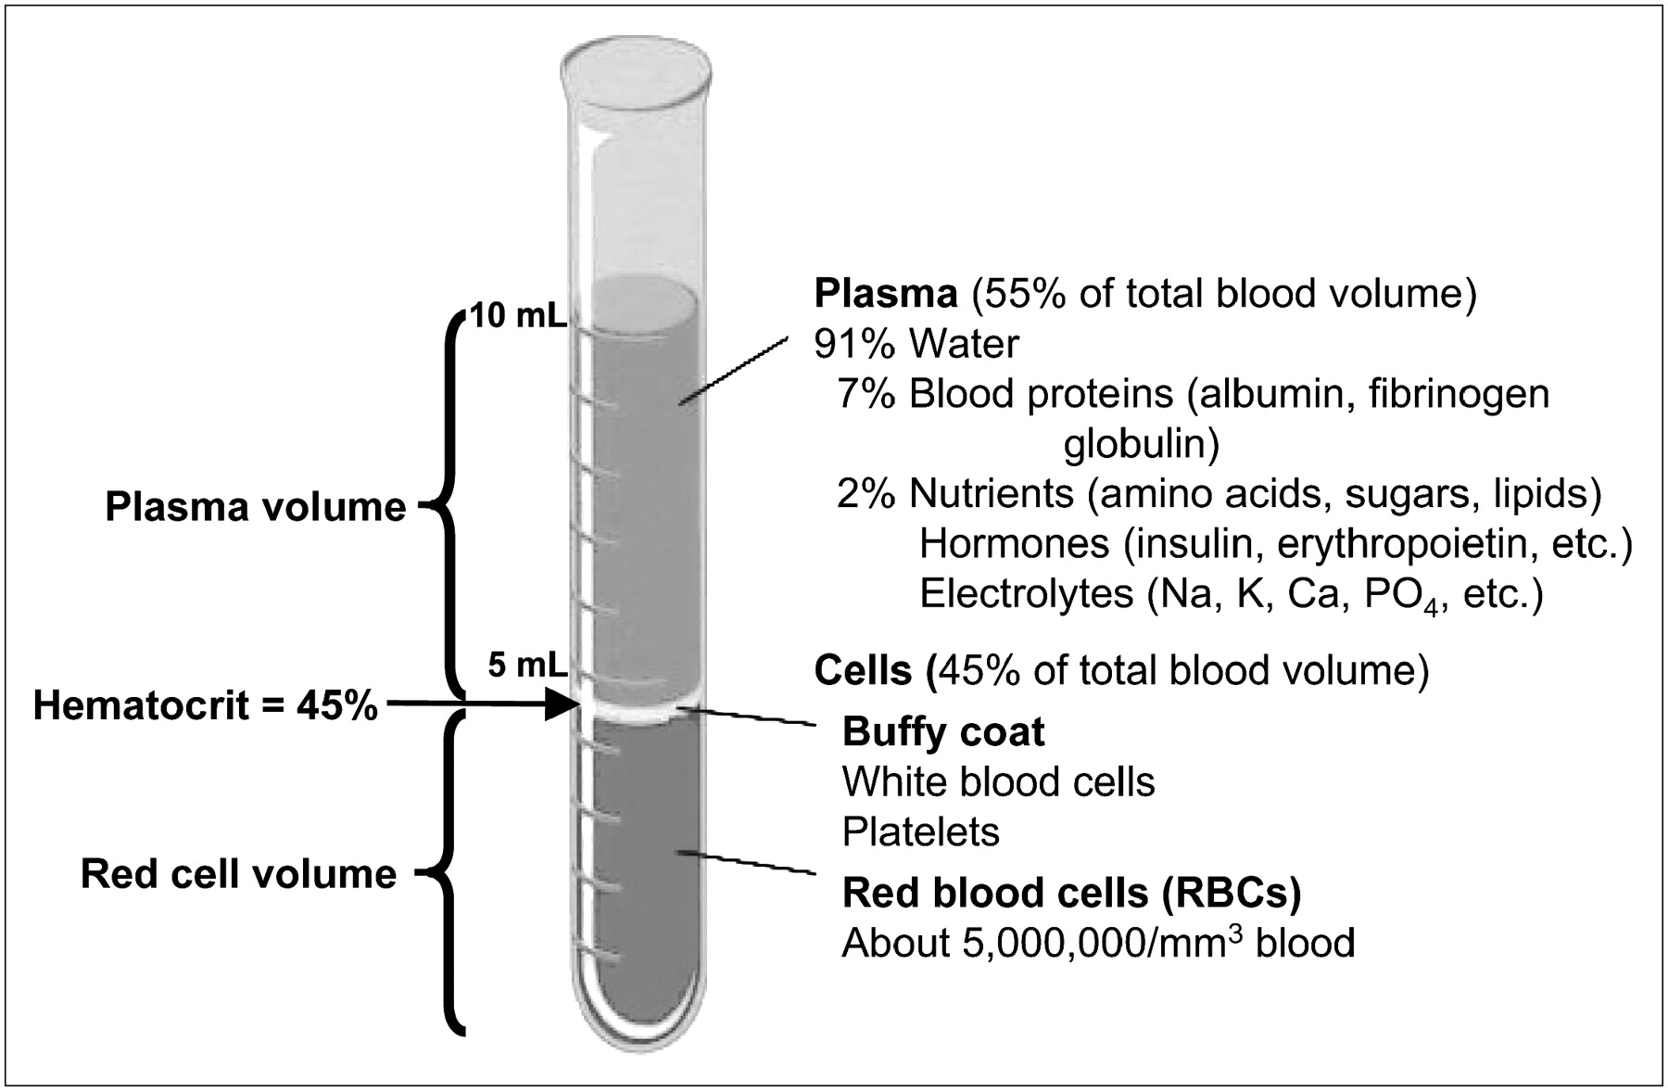
Heart and Associated Vessels

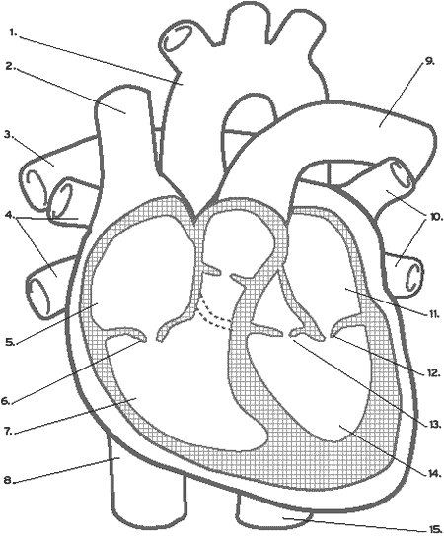

Types of Blood Vessels

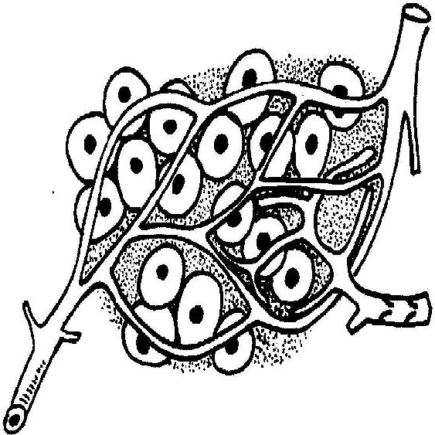
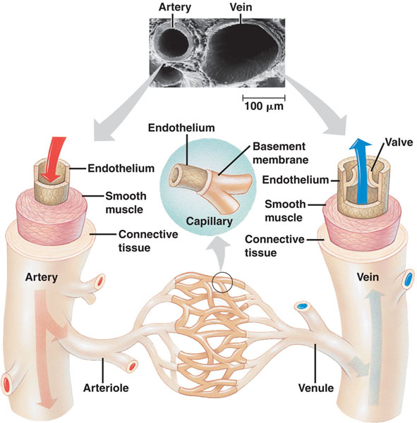

Respiratory System:

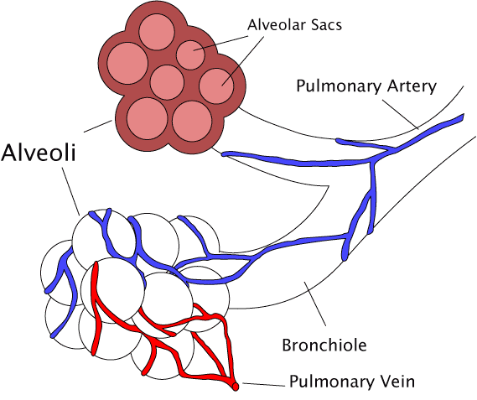
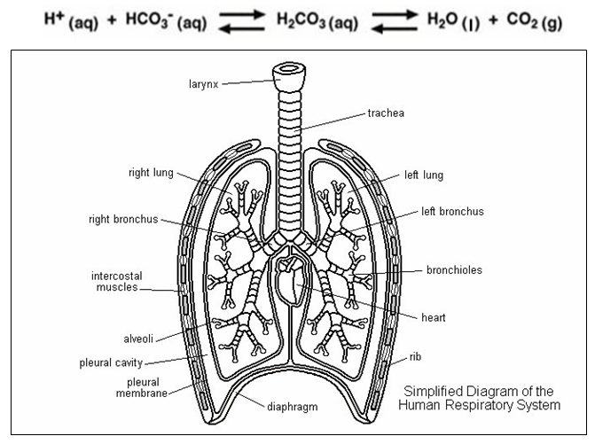

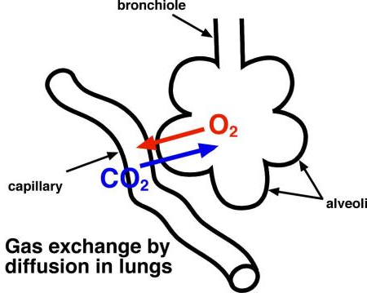
Excretory System:

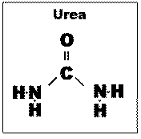
Nitrogenous wastes: made by protein and nucleic acid metabolism:
- Ammonia: very toxic, dissolves in water, excreted in aquatic animals
- Urea: less toxic, dissolves in water, made in liver, filtered by kidneys, excreted by many animals (mammals, worms)
- Uric Acid Crystals: not too toxic, pasty & insoluble, made in Malpighian tubules in arthropods, and also by birds, snails & reptiles. Ruins car paint.
- Urine: moderate toxicity, contains urea, salt, water, uric acid and tyrosine crystals, cholesterol, etc. Made by kidneys, urine is hyperosmotic to blood.

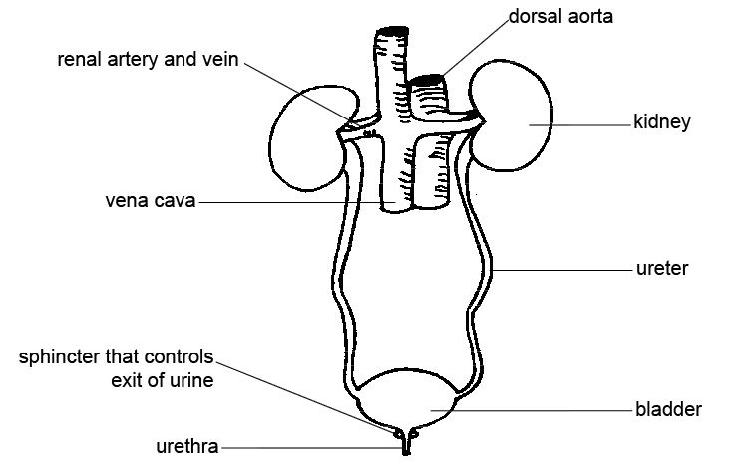
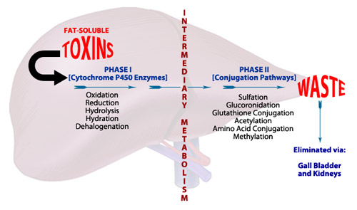

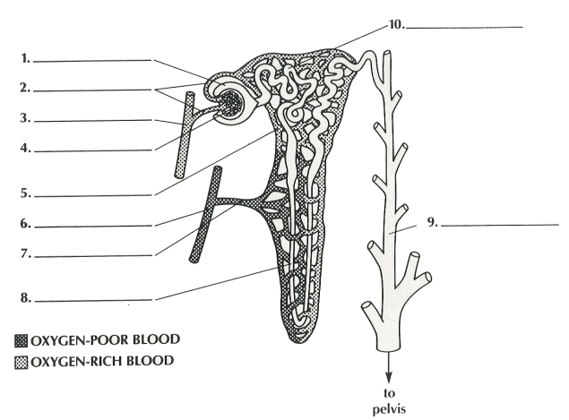
The 4 Steps to Urine Formation:
A. Filtration
B. Reabsorption
C. Secretion
D. Excretion

