Name Date

Define:

- Basement membrane:

- Lamina Propria:

- Goblet Cell:

- Mucosa:

- Epithelial Cells:

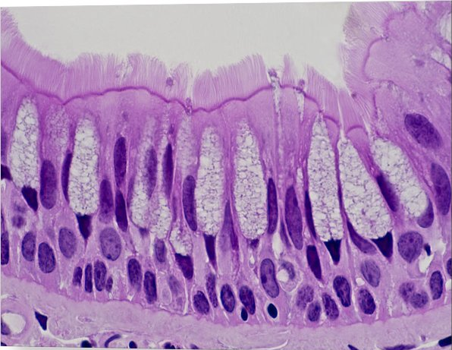
- Label the picture below according to the diagram on the SmartBoard.

