Name Date

- Using the diagram below, label the parts of the brain listed in the table and provide a brief explanation or definition of that part’s function.
Part of Nervous System | Function
Cerebrum
Cerebellum
Medulla Oblongata
Pons
Pituitary Gland
Retina
Frontal Lobe
Temporal Lobe
Parietal Lobe
Occipital Lobe
Beginning of Spinal Cord
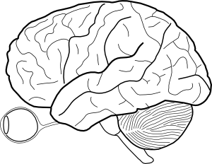

- Below is a graph of the electrical activity of a neuron called an action potential. Indicate what is occurring to sodium and potassium ions in a neuron for each labelled letter on the graph (are sodium and potassium inside or outside the nerve cell)?

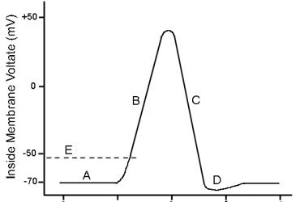

- Label the Neuron below. Next to each part, provide its function. Please label the synapse as well.
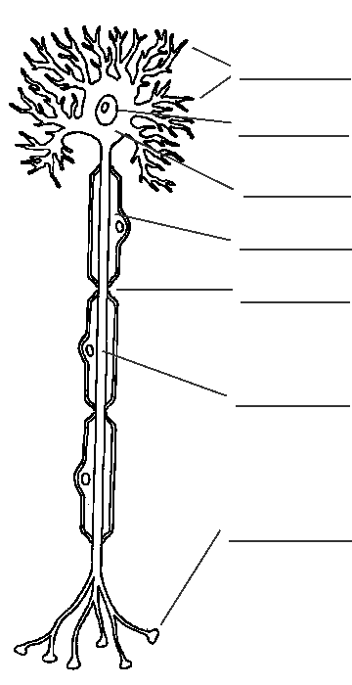

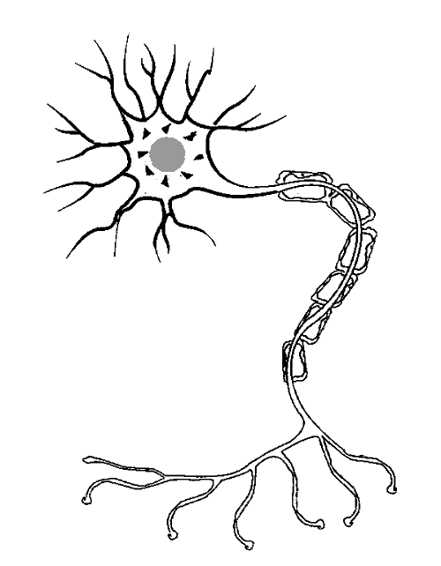

- This second neuron is called the “post synaptic neuron.”
Why?

- For both cells, show the direction of electrical activity by
drawing arrows.

